What happened
to the
chocolate?
There are 4 challenges to help you work out what happened to YOUR chocolate

Solve all 4 challenges,
submit your results and you could win the choc.

Who...took it ... faces and place value problems
What... type of chocolate...operations review
Where...it was taken from....% increase/decrease
Why...it was taken...mathematical statements
Challenge 1. Faces
Calculate the answers to the problems on the following page and decide which suspect told the truth each time. You can delete that suspect from your enquiries. You will be left with 1 suspect – the guilty one.
 | 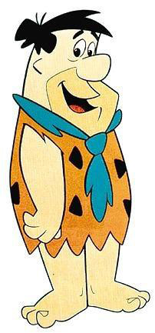 | 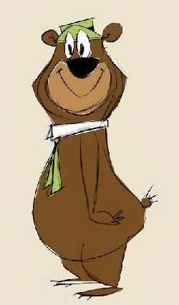
Suspect 1.  Homer Simpson | Suspect 2.  Fred Flinstone | Suspect 3.  Yogi Bear
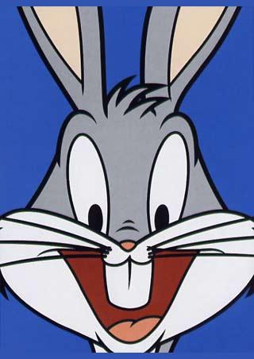 | 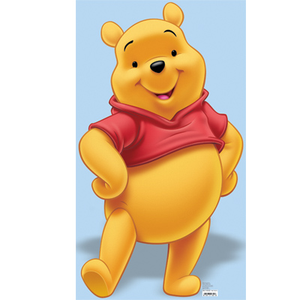 | 
Suspect 4. Bugs Bunny | Suspect 5. Winnie the Pooh | Suspect 6.  Mumble
Faces Problems
Problem 1
When asked to place the following in ascending order:
0.216, 0.126, 0.612, 0.0126, 2.16

Suspect 1 said  0.0126, 0.126, 0.216, 0.612, 2.16 |  | Suspect 2 said  2.16, 0.612, 0.216, 0.126, 0.0126
Suspect 3 said  0.612, 0.0126, 0.216, 2.16, 0.126 |  | Suspect 4 said  0.126, 0.0126, 0.216, 0.612, 2.16
Problem 2  When asked to place the following in descending order: 13%, 0.31, 30.1%, 1.13, 98%, 0.114 |  | Problem 3  When solving the following BIMDAS problem: (63-3) $÷$ 30 - 3²
Suspect 2 said  1.13,13%, 0.31, 30.1%, 0.114, 98% | Suspect 3 said  1.13, 98%, 0.31, 30.1%, 13%, 0.114 | Suspect 2 said  7 | Suspect 3 said  -1
Suspect 5 said  0.114, 13%, 30.1%, 0.31, 98%, 1.13 | Suspect 6 said  13%, 0.114, .31, 30.1%, 98%, 1.13 | Suspect 4 said  -7 | Suspect 6 said  1
Problem 4  When solving the following problem:  ((11 + 8) – (12$÷$4)²) x 5² |  | Problem 5  Jack receives $60 for his birthday. He saves a third of it, spends three quarters of what’s left on some music and buys a take-away with the rest. How much did the take-away cost ?
Suspect 5 said  It is 250 | Suspect 4 said  It is 50 | Suspect 2 said  It cost $5 | Suspect 3 said  It cost $20
Suspect 1 said  It is 2500 | Suspect 6 said  It is 190 | Suspect 5 said  It cost $15 | Suspect 6 said  It cost $10
Challenge 2. The chocolate
Decode the following to work out what type of chocolate was taken
a | b | c | d | e
200 ÷ 10 | 19 x 3 | 45 + 65 | 36 x 4 | 350 ÷ 70
f | g | h | i | j
420 ÷ 7 | 56 x 4 | 360 - 280 | 95 x 2 | Half of 66
k | l | m | n | o
3 x 50 | 600 ÷ 20 | 4 x 2 x 2 | 90 x 4 | 65 x 4
p | q | r | s | t
24 x 5 | 12 x12 x 2 | 450 + 350 | 18 x 3 | 100 - 36
u | v | w | x | Y or z
90 ÷ 3 | 15 x 5 | 48 ÷ 12 | 48 ÷ 4 | 45 x 4

Now write the letters into this above their number to reveal the message..
190 | 64 | 190 | 54 | 20 | 57 | 190 | 224 | 57 | 260
12 | 260 | 60 | 110 | 5 | 30 | 5 | 57 | 800 | 20
64 | 190 | 260 | 360 | 54 | 110 | 80 | 260 | 110 | 260
30 | 20 | 64 | 5 | 54 | 16 | 16 | 16 | 16 | 16

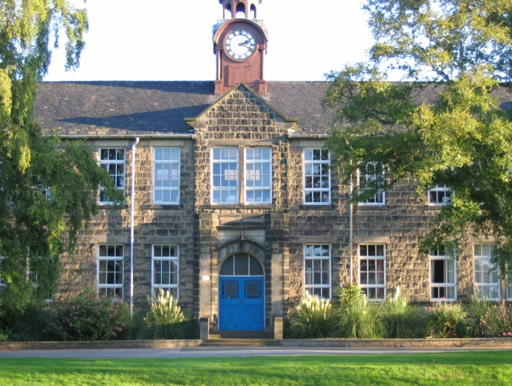
Challenge 3.
The place the chocolate was taken from one of the following rooms at BSC.
07-214: 54.8 | 03-203: 176
Reception: 70% | Library: $462.50 | PAC: $150

Solve the following equations. The number which is NOT an answer is the room where the crime was committed
Decrease $200 by 12%
Increase $50 by 9.6%
14/20 = 70%
A 10% increase of $125
A 7.5 % decrease of $500

Challenge 4.
Decide which of these mathematical statements are true. If true, you can cross off the matching number in the reasons table.
Statement 1 | 361 is a square number
Statement 2 | 25 is the square root of 655
Statement 3 | 3375 is a cube number
Statement 4 | 42 is the square root of 1764
Statement 5 | 16 is the cube root of 4096

I took it to share with my maths class | 1
I just love chocolate, I was going to eat it all myself | 2
I wanted to give my favourite teacher a special present | 3
I’m sorry, I had a mad moment – that’s what chocolate does to me. | 4
I wanted to give it to a charity | 5

Our accusation is.....
Who took it
What was taken
Where it was taken from
Why it was taken

Teacher answer sheet
Who took it | Fred Flinstone  (suspect 2)
What was taken | It it a big box of celebrations mmmm
Where it was taken from | PAC
Why it was taken | I just love chocolate, I was going to eat it all myself.

